General Vocabulary

🗣️ What is General Vocabulary
# Source: AI Source: Provided by: [Data Path: Persons Table -> ID Column: 1, Name_En Column: Motasem Essam] -> From: [Chatgpt (GPT-4-turbo)] on [7/30/2025]
General vocabulary refers to words used in everyday communication, across a wide range of non-specialized contexts. These words are commonly understood by most speakers of the language and are not tied to any specific domain or discipline.

✅ Key Features:
# Source: AI Source: Provided by: [Data Path: Persons Table -> ID Column: 1, Name_En Column: Motasem Essam] -> From: [Chatgpt (GPT-4-turbo)] on [7/30/2025]
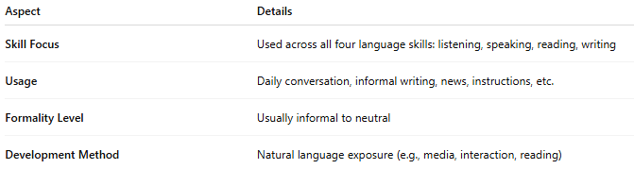
Aspect | Details
Skill Focus | Used across all four language skills: listening, speaking, reading, writing
Usage | Daily conversation, informal writing, news, instructions, etc.
Formality Level | Usually informal to neutral
Development Method | Natural language exposure (e.g., media, interaction, reading)

🧠 Examples:
# Source: AI Source: Provided by: [Data Path: Persons Table -> ID Column: 1, Name_En Column: Motasem Essam] -> From: [Chatgpt (GPT-4-turbo)] on [7/30/2025]
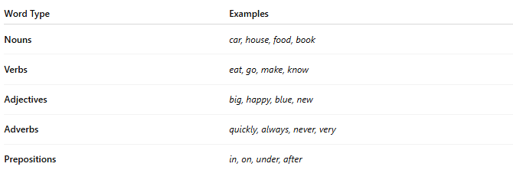
Word Type | Examples
Nouns | car, house, food, book
Verbs | eat, go, make, know
Adjectives | big, happy, blue, new
Adverbs | quickly, always, never, very
Prepositions | in, on, under, after

👤 Who Uses It?
# Source: AI Source: Provided by: [Data Path: Persons Table -> ID Column: 1, Name_En Column: Motasem Essam] -> From: [Chatgpt (GPT-4-turbo)] on [7/30/2025]
- Everyone, including:
  - Native speakers
  - Language learners
  - Children acquiring vocabulary
  - Adults in daily communication

📌 Related Vocabulary Types:
# Source: AI Source: Provided by: [Data Path: Persons Table -> ID Column: 1, Name_En Column: Motasem Essam] -> From: [Chatgpt (GPT-4-turbo)] on [7/30/2025]
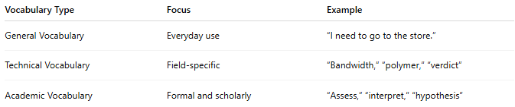
Vocabulary Type | Focus | Example
General Vocabulary | Everyday use | “I need to go to the store.”
Technical Vocabulary | Field-specific | “Bandwidth,” “polymer,” “verdict”
Academic Vocabulary | Formal and scholarly | “Assess,” “interpret,” “hypothesis”

